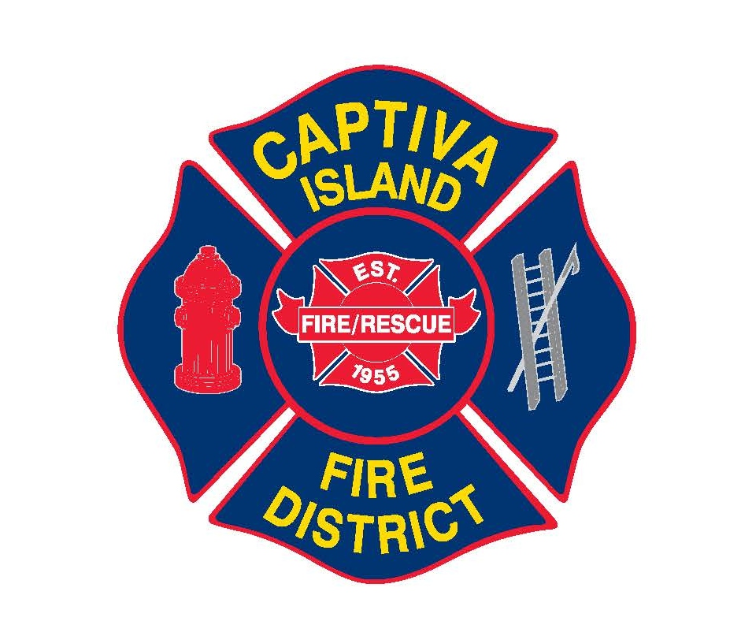 | Captiva Island Fire Control District  14981 Captiva Drive; P.O. Box 477, Captiva, Florida 33924 Phone: (239) 472-9494
Captiva Island Fire Control District
Commission Meeting Minutes
May 13, 2025

Call Meeting to Order
Commissioner Brown called the meeting to order at 11:00 am. Commissioners Sims, Campbell, Brown, Chief Pawul, and Samantha Quinn, Laura Donaldson (District attorney) present.

Minutes from Regular Board Meeting
April 8th Meeting minutes reviewed and approved/ signed. Commissioner Campbell made the motion to approve, second by Commissioner Sims, no discussion.

Consent Agenda
- Items for approval-
  - 2025-08- Ice Maker
  - 2025-09- Highwater Vehicle
- Items to be pulled for discussion by the Board- N/A
- Motion to approve balance of the items- Motion by Commissioner Sims, second by Commissioner Campbell, all in favor, motion carries.
Financial Statements
Financial statements through April 30, 2025, were reviewed and approved.

Administrative Update
- Personnel responded to 51 emergencies for the month of January; 73 fire inspections were completed. Personnel compensated absences reviewed through April 30, 2025.

Operations Update

- Fire Chief
- Zoning hearing South Seas Resort- the proposed language for the cost of the apparatus has been rejected by Lee County Assistant County attorney with the recommendation that the FD enter into a separate agreement with South Seas Resort if that is the goal of both entities. The District’s attorney is working with the attorney from South Seas Resort to craft a separate agreement to accomplish the funding of the truck. To this date, there has been no agreement received from their attorney. The Chief and our attorney will continue to work on the process.
- District Funding (assessment, property taxes, combination method)- the District’s attorney spoke in detail to explain the process of amending the funding source for the District. The District’s charter currently allows for assessments, so that would not need to be amended, but a referendum approving the amount would need to go to a vote of the District voters. The first step of the process is to do a financial study to determine the needed amount and determine the methodology for setting the assessment, followed by educating the public on the purpose of the assessment so it is clear we are not asking for more money, but rather changing the method we are funding the District to make the process more equitable for all the residents. This is the toughest part as most people hear the term “assessment” and think extra or another fee. Finding a good firm to do the study is also very important. The earliest we could implement the change would be in 2027. The referendum would go to a vote in the 2026 general election to take affect the following fiscal year.
- Legislative update- many bills are proposed during this year’s legislation. Two (2) bills that could significantly impact the District would be (1) elimination of property taxes (2) Firefighter mental health, limiting work hours for FF’s to 42 hrs/ week. The mental health bill is expected to be signed soon. What the implication to the District is going to be is still unknown. Most employees at the District do not want to switch shifts our shift schedule from 48/96 to 24/72 to limit working hours, but we have to see what the final bill and rules say are required.
- Audit Update- audit expected to be completed in May with a presentation to be performed at the June meeting.
- Apparatus- There is no further update, Chief is still working with Pierce on a stock unit that will save time and money on the apparatus.

Board items

General Business

New Business

Next meeting to be held on June 10, 2025 at 11:00 am.

Public Comment

Shawn Ferrell from South Seas Resort attended the meeting, thank you for allowing him to attend and he appreciates the good working relationship we have and continue to have together.

Motion to adjourn by Campbell, second by Commissioner sims, meeting adjourned by Commissioner Brown at 11:56 am.

Jeff Brown _______________________________________________________________________________

Sherrill Sims _________________________________________________________________________________

Carole Campbell _________________________________________________________________________________

